## Examples

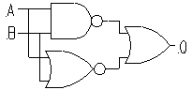

Q = ¬ (A ∧ B) ∨ ¬ (A ∨ B)

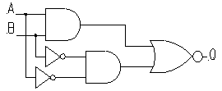

Q = ¬ ((A ∧ B) ∨ (¬A ∧ ¬B) )

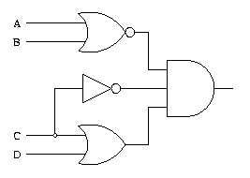

Q = ¬ (A ∨ B) ∧ (C ∨ D) ∧ ¬ C

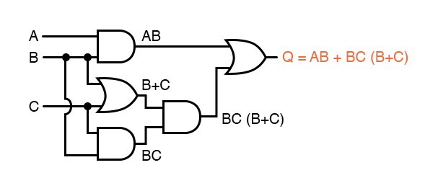

Truth Table

|  |  |  |  |  |  |  |  |
| --- | --- | --- | --- | --- | --- | --- | --- |
| A | B | C | AB | BC | B+C | BC(B+C) | AB + (BC(B+C)) |
| 0 | 1 | 1 | 0 | 1 | 1 | 1 | 1 |
| 0 | 0 | 0 | 0 | 0 | 0 | 0 | 0 |
| 1 | 1 | 0 | 1 | 0 | 1 | 0 | 1 |
| 1 | 0 | 1 | 0 | 0 | 1 | 0 | 0 |

## Exercise

Write the following logic circuits as Boolean expressions and derive the truth table for the diagrams below;

